PILLOW CASE

---- 3 Straight Seams --- No Frayed Edges or Serger Stitch

Fabric requirements

Standard Queen

This will make 2 pillow cases

1 – focus fabric for body - 1 yard
1 – focus fabric for band – 1yard
1 – focus fabric for accent - 4 inches x WOF (width of fabric)-optional

Option:
If you prefer to have both pillow cases to be the same –

1 ½ yards of main fabric for the case.
½ yard of fabric for the band.
4 inches for the accent strip

Both 1 yard piece of fabrics - square up fabric and cut 1 strip - 9 inches by WOF and one strip 27 inches by WOF

Accent fabric: square up fabric and cut 2 strips 2 inches x wof.

Press your accent piece in half (wrong sides together) so that the pretty part is on the outside.

Assembly:

Lay your band the strip that is 9x(wof) face up (pretty side up)

On top of that place your accent strip with raw edges meeting at top edge

Then your pillowcase fabric on top of both the accent strip and band, right sides together. At this point I pin in place(you will be moving these pins in a moment) so I pin with the heads of the pins sticking out of the sandwich. – see picture

The Tube Assembly
I then gather up the body of the pillow case fabric as neatly as I can and bring around the other part of the band to meet where the pins have been placed and re-pin this time making sure only the edges of each part are caught, pillow case, the accent strip and the band. PIN. Bring this tube to the sewing machine and stitch. I use a 2.0 stitch and a 3.5 (center position for my needle)- Back tack at each end. Make sure all layers are being caught. Don’t worry about having each piece be even, we will be trimming.

Once both pillow cases are stitched pull out the fabric from the tube. Press the band on the “inside” of the pillow case first then the “outside”. A general Pressing all over at the same time will make things easier to match up.

Next, fold in ½ lengthwise – wrong sides together, trim the side and bottom so that they are even and squared up. I pin these together making sure the band and cuff are matching at the intersections. REMEMBER THESE ARE WRONG SIDES TOGETHER . I stitch down the raw edge side using a 6.0 stitch and continue along the bottom. Turn inside out and match seams as best you can and press.

The French seam:

Now for your 3rd and final seam to give these pillow cases a finished look on the inside as well as the outside. You will stitch your seam again but on the wrong side, taking a deep stitch (I place my needle the furthest to the left) .05 so that all the raw edges on the front side are encased in this seam. Back tack at the beginning and end. Turn right side out and press again. Make sure there are no pieces of raw edges sticking out (yes sometimes it happens to me) and if that’s the case, you may be able to trim them or just re-stitch the seam taking a deeper width.

Option:
If you prefer your both pillow cases to be the same –

1 ½ yards of main fabric for the case.
½ yard of fabric for the band.
4 inches for the accent strip

Cut Fabric Press accent piece in 1/2

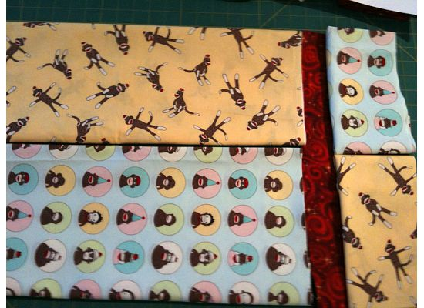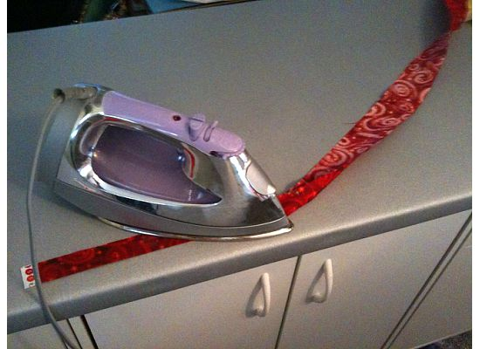

Pin the 3 pieces right sides together Roll up case towards cuff

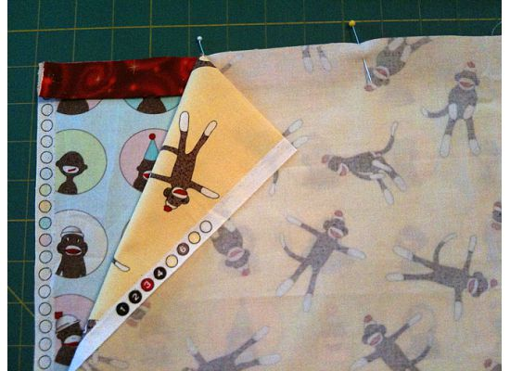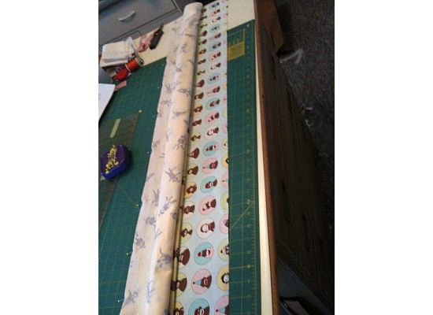

Re-pin hot dog roll Roll done and ready to sew

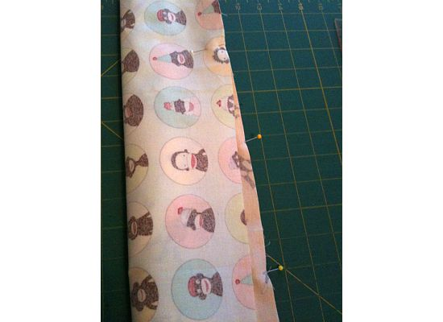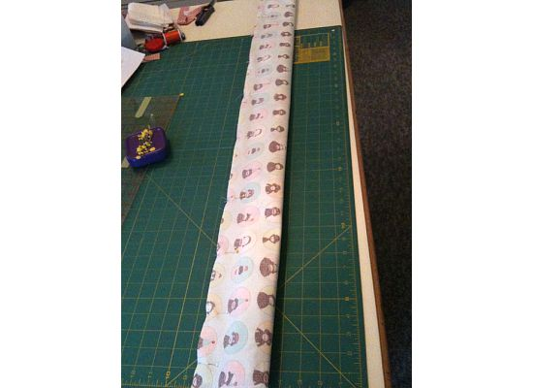
Stitch hot dog using 3.5 center needle position Press back side first
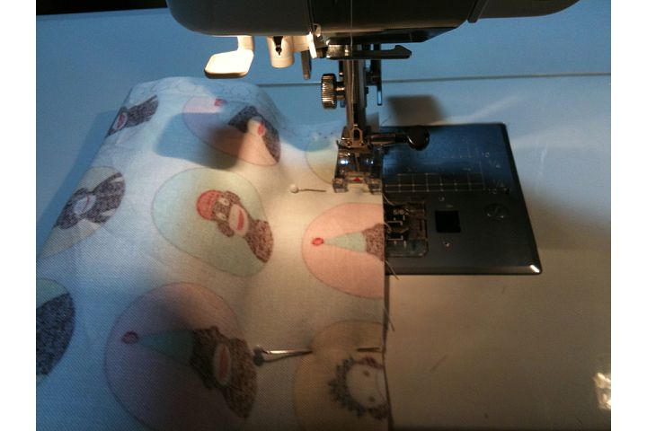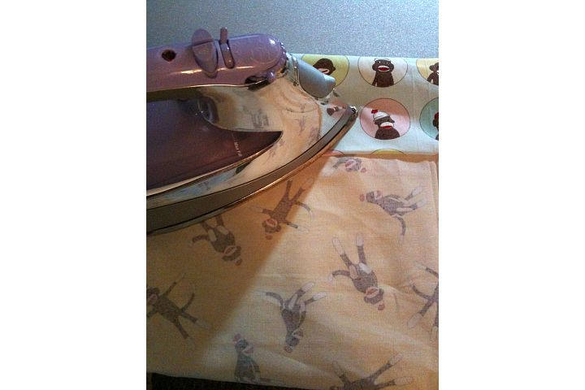

Now press the front making sure cuff is not folded Square up raw edges
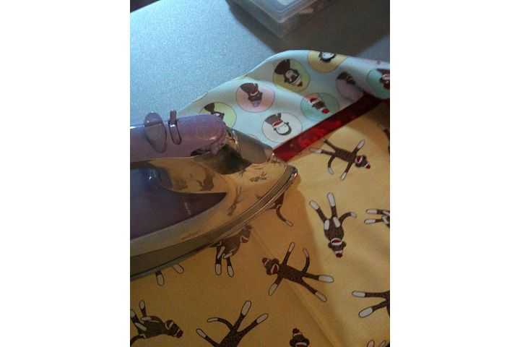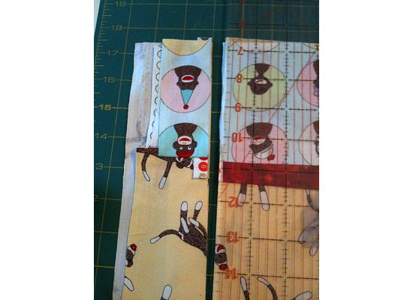

Pin with wrong sides together Stitch using the 6.0 width
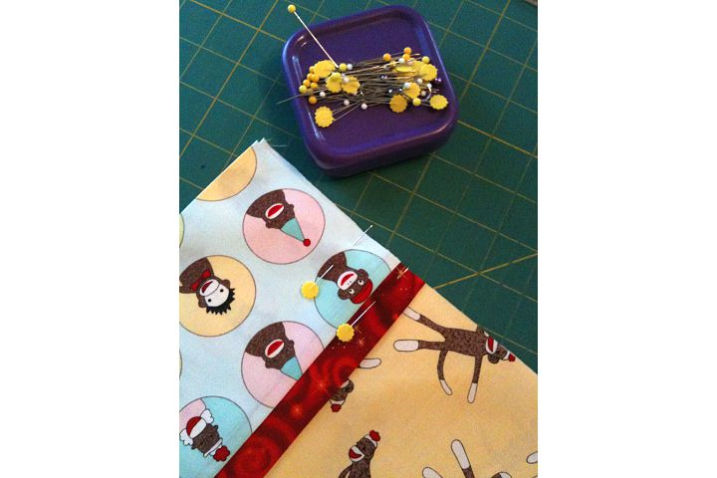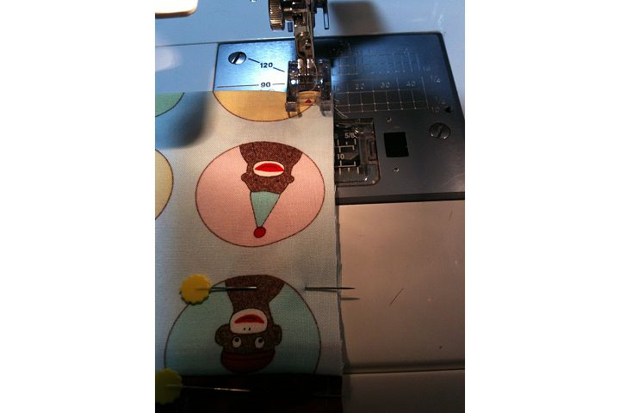

Press seam Stitch your final seam r/s together
Using a .05 needle position

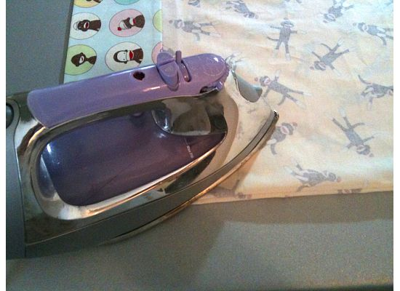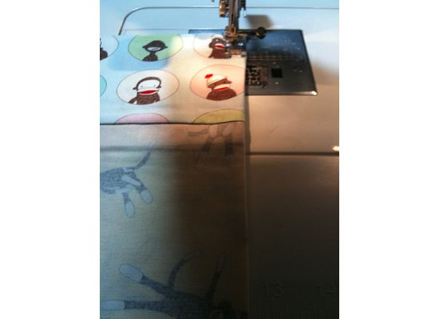
Press again and make another using the opposite color way.

