Disappearing 9 patch – chain stitching

Select your fabrics and lay them out.
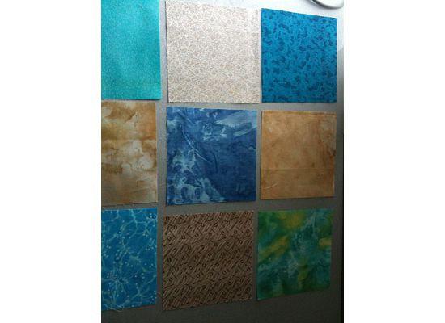

Cover your squares, middle section on top of left section, keeping them in order - left top, left middle and left bottom.

I pick up with the top 2 first, then the middle and finally the last 2 and bring to my machine piled in that order so I know how to sew. The final three from the right are brought to the machine and set aside.

I piece the first section, do not cut the thread but then add the middle section keep sewing and add the bottom 2 squares.

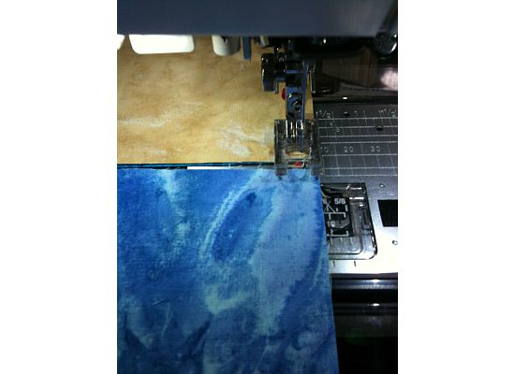

You will now have 3 sets of 2 chained together so there is a thread holding all 6 pieces together between sections
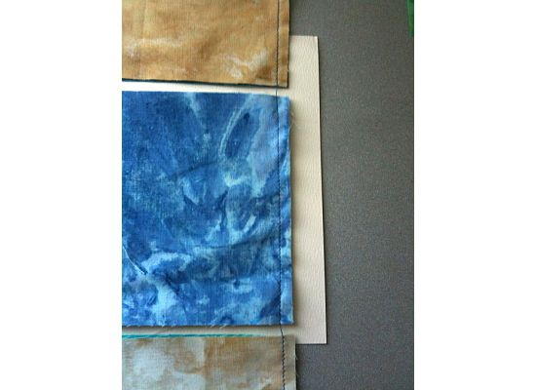

Open the 3 sections and find the last three squares that you want to add. (still not cutting any thread!) Next add the top right square to the top 2 that you have already sewed, then the middle right to the middle section that you already sewed – again not breaking the chain and finally the lower right to the 2 you have already sewed.

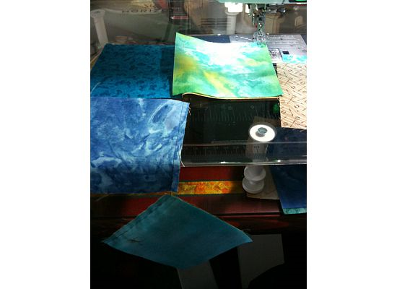

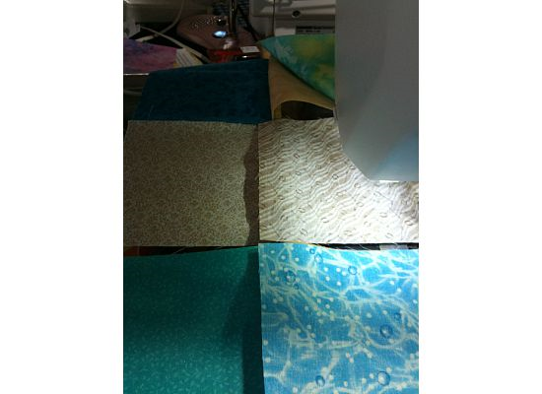

You will now have all nine squares together but just holding on to each other by threads.

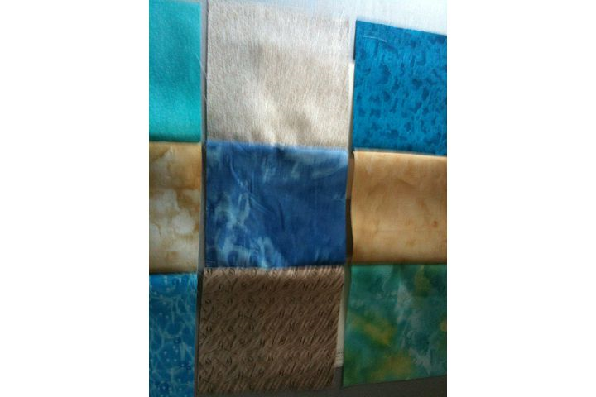

No pressing yet! Just fold down the top row onto the middle row, I pin the intersections in the middle and sew the top row to the middle.

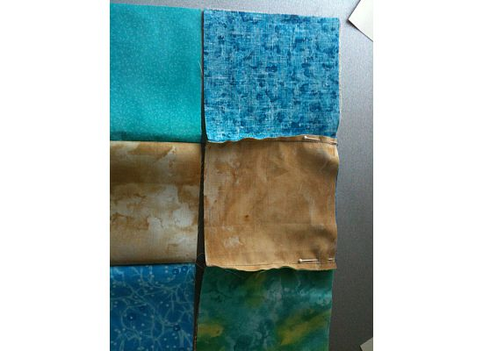

Then join the top 2 rows to the 3rd row in the same manner, pinning then sewing.

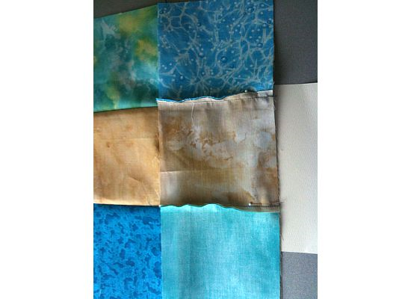

NOW you can press the seams as you want – see how I did it.

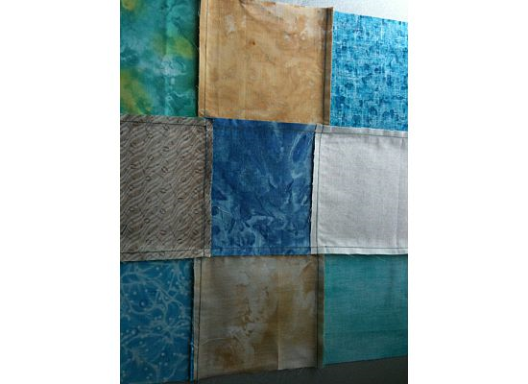

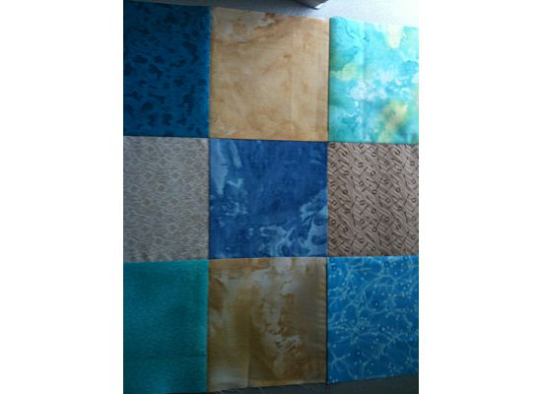

Bring over to the cutting table and using the ruler of your choice, I use a big square cut in have as per picture.

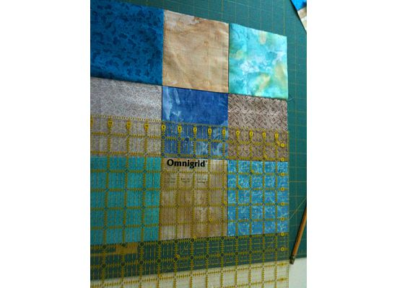

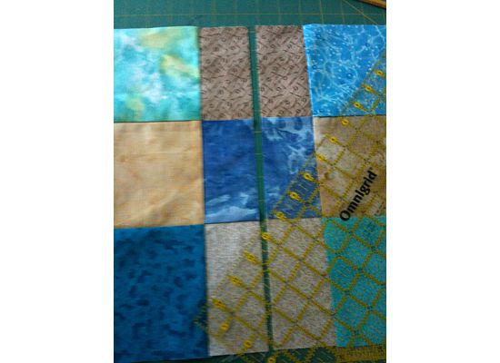
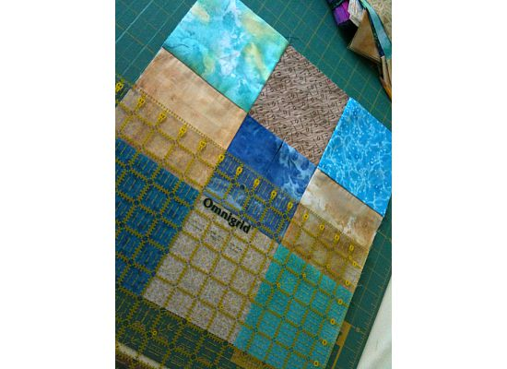

You now have 4 squares to mix with other disappearing 9patches.
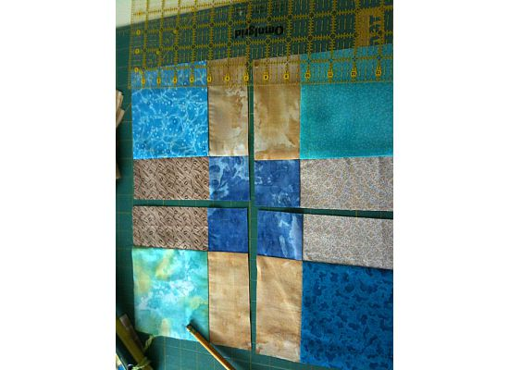

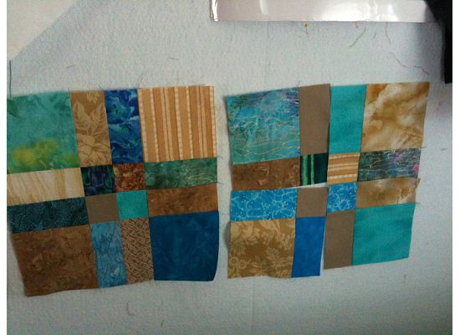

You can use the same chain piecing method when you sew the 4 squares together – of course after you mix them up.

See how easy ….. I have actually put together an entire quilt top like this, you just need to be organized.

denise

